INTRODUCTION:

School children in Liberia are desperate for textbooks. They need our help. The La Mesa Sunrise Rotary Club is partnering with Compassion for African Villages and a number of other charitable organizations and individuals to gather and deliver 130,000 schoolbooks to needy students in Liberia. Our goal is to complete the book drive by the end of July and to ship the books to Liberia in August.

We need your support. The projected total cost for the book drive is $15,000. A generous anonymous donor to Compassion for African Villages has pledged matching funds up to $10,000 to help stimulate donations for the book drive. Your contributions will help to ensure the success of the book drive. Your gift to the schoolchildren in Liberia would be of incalculable value to them.

Compassion for African Villages (CAV) is a San Diego based, all volunteer, nonprofit, 501(c)3 charitable organization dedicated to working with African villagers to develop sustainable equitable educational resources.

CAV was founded in San Diego in 2007 by the late Ms. Tsitsidzashe Mutseta.
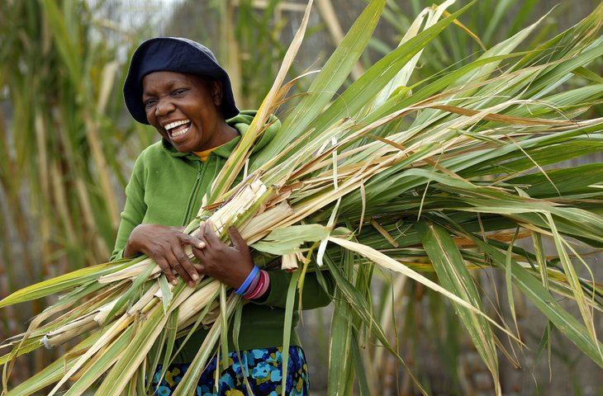
Tsitsi Mutseta, founder of Compassion for African Villages, photo courtesy San Diego Union Tribune

Tsitsi grew up in the small rural village of Rundogo in Makoni Land, Zimbabwe. Rundogo, like many villages in Africa, has been ravaged by AIDS and poverty. She bravely left her home to study Public Health in San Diego at SDSU. Her plan was to return to her village and work to improve the lives of the children in the region. While pursuing her dream, Tsitsi was diagnosed with stage-IV breast cancer. Tsitsi lost the battle against cancer in October, 2013 at age 46. She inspired her friends and family, the current leadership of CAV, to work to keep her dream of compassion for African villagers alive.

THE PARTNERS:

Compassion for African Villages envisions a world in which those who have resources and those who need resources love and respect each other and work together to enrich each other’s lives.
Mark Wheeler, President, and Alexandra Hart, Secretary, are Members of LMSR

Rotary International is an international service organization whose stated human rights purpose is to bring together business and professional leaders in order to provide humanitarian services, encourage high ethical standards in all vocations, and to advance goodwill and peace around the world. It is a secular organization open to all people regardless of race, color, creed, religion, gender, or political preference. Rotary Clubs in different parts of the world corroborate to do projects. Rotary Clubs of El Cajon Sunset and Sinkor in Monrovia will partner on this project. Dr. Angela Benson MD is the President (17/18).

Richard Makau is President of the El Cajon Sunset Rotary Club. He works tirelessly on behalf of the needy in many African countries.

Lily Alba, age 11, has been collecting books for kids for over 5 years. She donates books to schools and children who don't have books. As a Rotar-kid she is supported enthusiastically by her fellow Rotarians at La Mesa Sunrise Rotary.

Robert Saah founded and led Books for Liberia. He is from Liberia, sponsored by LMSR and is a student at Mesa College. His organization collects school supplies for K-12 grade children in Liberia.

Orphan Cry International, a non-for-profit organization, located in Johnson City, NY has worked with orphan children in Liberia over the years and will assist in raising funds; and make connections with Rotary clubs in the northeast region for this project. Orphan Cry will also assist in providing a team of local volunteers in Liberia for distribution purposes. For more information on Orphan Cry, please visit: www.orphancryinternational.org

We Care Foundation is a Liberia nonprofit volunteer organization based in Liberia, and will help handle distribution of the books.

THE NEED:
About Liberia: According to USAID, Liberia is “significantly behind most other countries in the African region in nearly all education statistics.” (See https://www.usaid.gov/liberia/education)
UNICEF reports the following facts (http://www.unicef.org/liberia/children_7916.html):

- The 2010/2011 National School Census reported a Net Enrolment Rate (NER) for primary education at 44% (46% for boys and 42% for girls) and Gross Enrolment Rate (GER) at was 111%. There are ‘children’ aged over 20 still in primary school, even in Grade 1. This shows a huge hunger for education, a hunger not being satisfied.
- During the 14-year civil conflict which ended in 2003, 80% of schools were destroyed or damaged; many had roofs, furniture and supplies looted. Since government investment in basic education outside the capital city was low before the war, and despite a brief window of reconstructive effort between 1999-2000, further conflict and the operational cessation of the Ministry of Education left schooling in a parlous condition. A rapid assessment in 2004 showed that only 24% of children in public primary school had desks or benches and that there were 27 children to each book.
- The problem of extremely low quality schooling – schools not able to teach students enough to reach Grade 4 – is significant. Of those teaching in primary schools, only 40% are trained, and many also have to teach at pre-primary and at high school levels. Of all primary teachers, trained and untrained, only 12% are female.
- Over a quarter of a million 6 to 11 year old children have never been to school as per the UNESCO and UNICEF Out-of-School Study of 2011.

WHY COLLECT AND SHIP BOOKS TO LIBERIA?
It meets the objective mission of CAV and fills a lack of books that exists in school in Liberia from the glut of quality books in the USA

SHIPPING BOOKS TO LIBERIA VERSES BUYING IN LIBERIA:
Shipping books guarantees more than 100,000 books will be delivered to schools in Liberia.
Purchasing books locally for $15,000, translate to less than 400 books for college level and/or less than 7000 books for K – 12 grades. The majority of books shipped will not be available in Liberia for purchase, therefore CAV and Rotary will provide an extremely life fulfilling service that would otherwise not be available in Liberia.

THE PROJECT:

Book Drive for School Children in Liberia

Funds and Books to be collected:
- Funds for all shipping expenses ($15,000)
- School Books, new and gently used:
CURRENT Math (algebra, geometry, calculus); Science (biology, physics, chemistry); English (reading, writing, composition); Peace; Geography; Social Studies; Dictionaries; Thesauruses; Business (sewing, food, nutrition) Novels; "How to books" (how to cook, repair cars, radio, art, music and technology); Teacher instruction manuals and resource books on any subject; World map and Africa wall map; Baby books

Where to direct your donations:
- Funds should be donated to Compassion for African Villages (CAV). Visit compassionforafricanvillages.org, and donate using PayPal. Or contact Mark Wheeler, CAV President, at 619-582-5893.
- Books can be dropped off at the shipping container, located at SDSU. Please contact Richard Makau, President of the El Cajon Sunset Rotary Club, at 619-266-0366, or Mark Wheeler, CAV President, at 619-582-5893 or email the team at rotaryandcavproject@gmail.com

When collection begins:
- Funds for the shipping expenses needed immediately
- Books and school supplies are being collected. If you wish to donate books and school supplies, please contact Richard Makau for more information.

Please contact us for even more budget details or shipping logistics if needed.

